1. Buka comp berisi beberapa layer → klik Read context → muncul JSON; cek datanya benar.
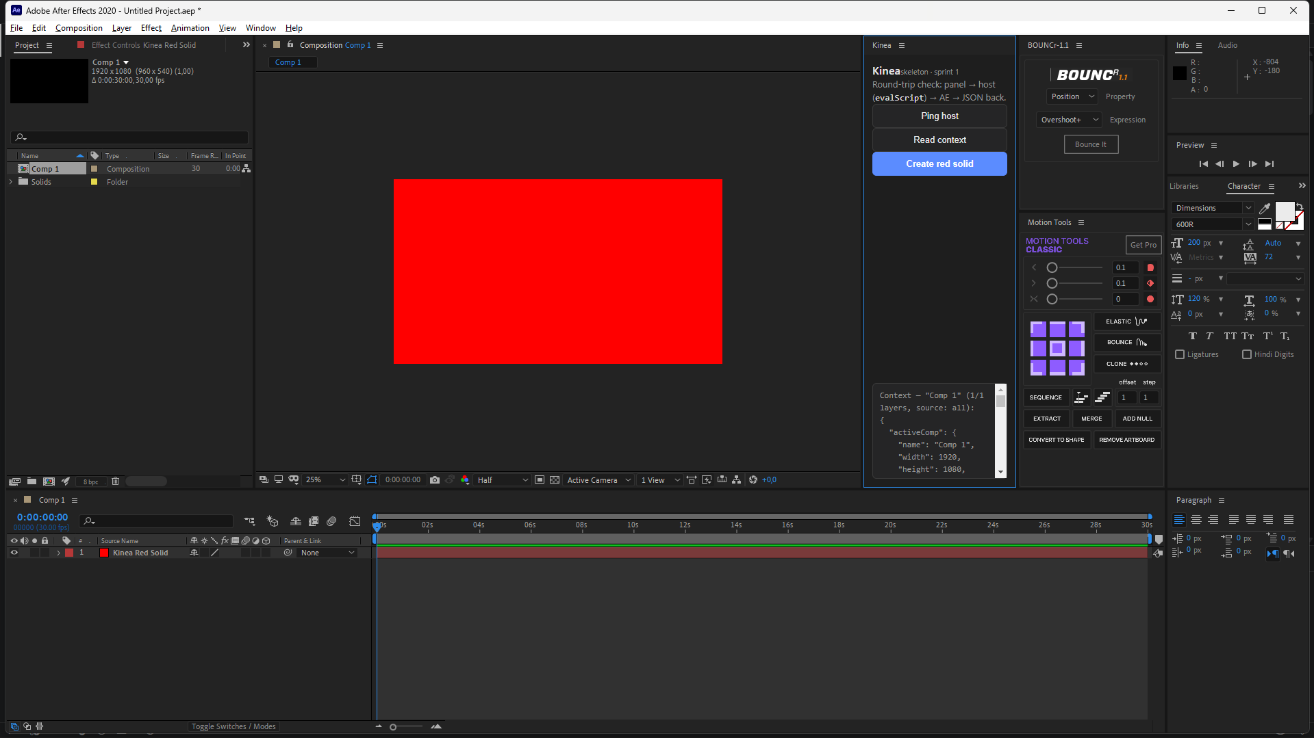
Context — "Comp 1" (1/1 layers, source: all):
{
"activeComp": {
"name": "Comp 1",
"width": 1920,
"height": 1080,
"frameRate": 30,
"duration": 30,
"currentTime": 0,
"numLayers": 1
},
"layerSource": "all",
"layers": [
{
"index": 1,
"name": "Kinea Red Solid",
"type": "av",
"enabled": true,
"transform": {
"position": [
960,
540,
0
],
"scale": [
100,
100,
100
],
"rotation": 0,
"opacity": 100,
"expressions": []
}
}
],
"truncatedLayers": false,
"selectedProperties": [],
"projectTree": [
{
"name": "Comp 1",
"layers": 1
}
]
}
2. Pilih satu layer → klik lagi → harusnya source: selection dan cuma layer itu.
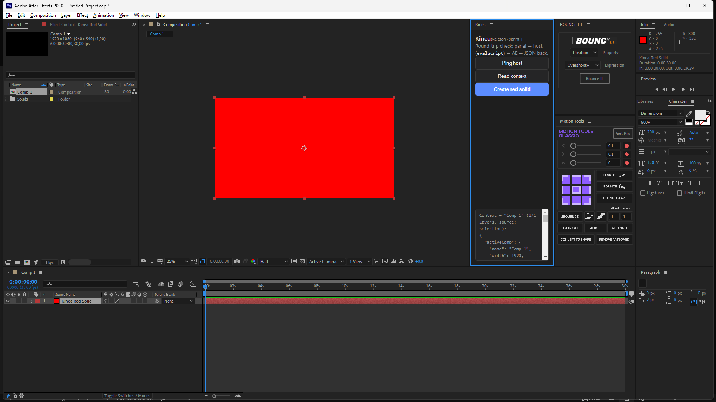
Context — "Comp 1" (1/1 layers, source: selection):
{
"activeComp": {
"name": "Comp 1",
"width": 1920,
"height": 1080,
"frameRate": 30,
"duration": 30,
"currentTime": 0,
"numLayers": 1
},
"layerSource": "selection",
"layers": [
{
"index": 1,
"name": "Kinea Red Solid",
"type": "av",
"enabled": true,
"transform": {
"position": [
960,
540,
0
],
"scale": [
100,
100,
100
],
"rotation": 0,
"opacity": 100,
"expressions": []
}
}
],
"truncatedLayers": false,
"selectedProperties": [],
"projectTree": [
{
"name": "Comp 1",
"layers": 1
}
]
}
3. Tambah ekspresi (mis. wiggle(2,30) di Position), pilih propertinya → klik lagi → teks ekspresi muncul di output.
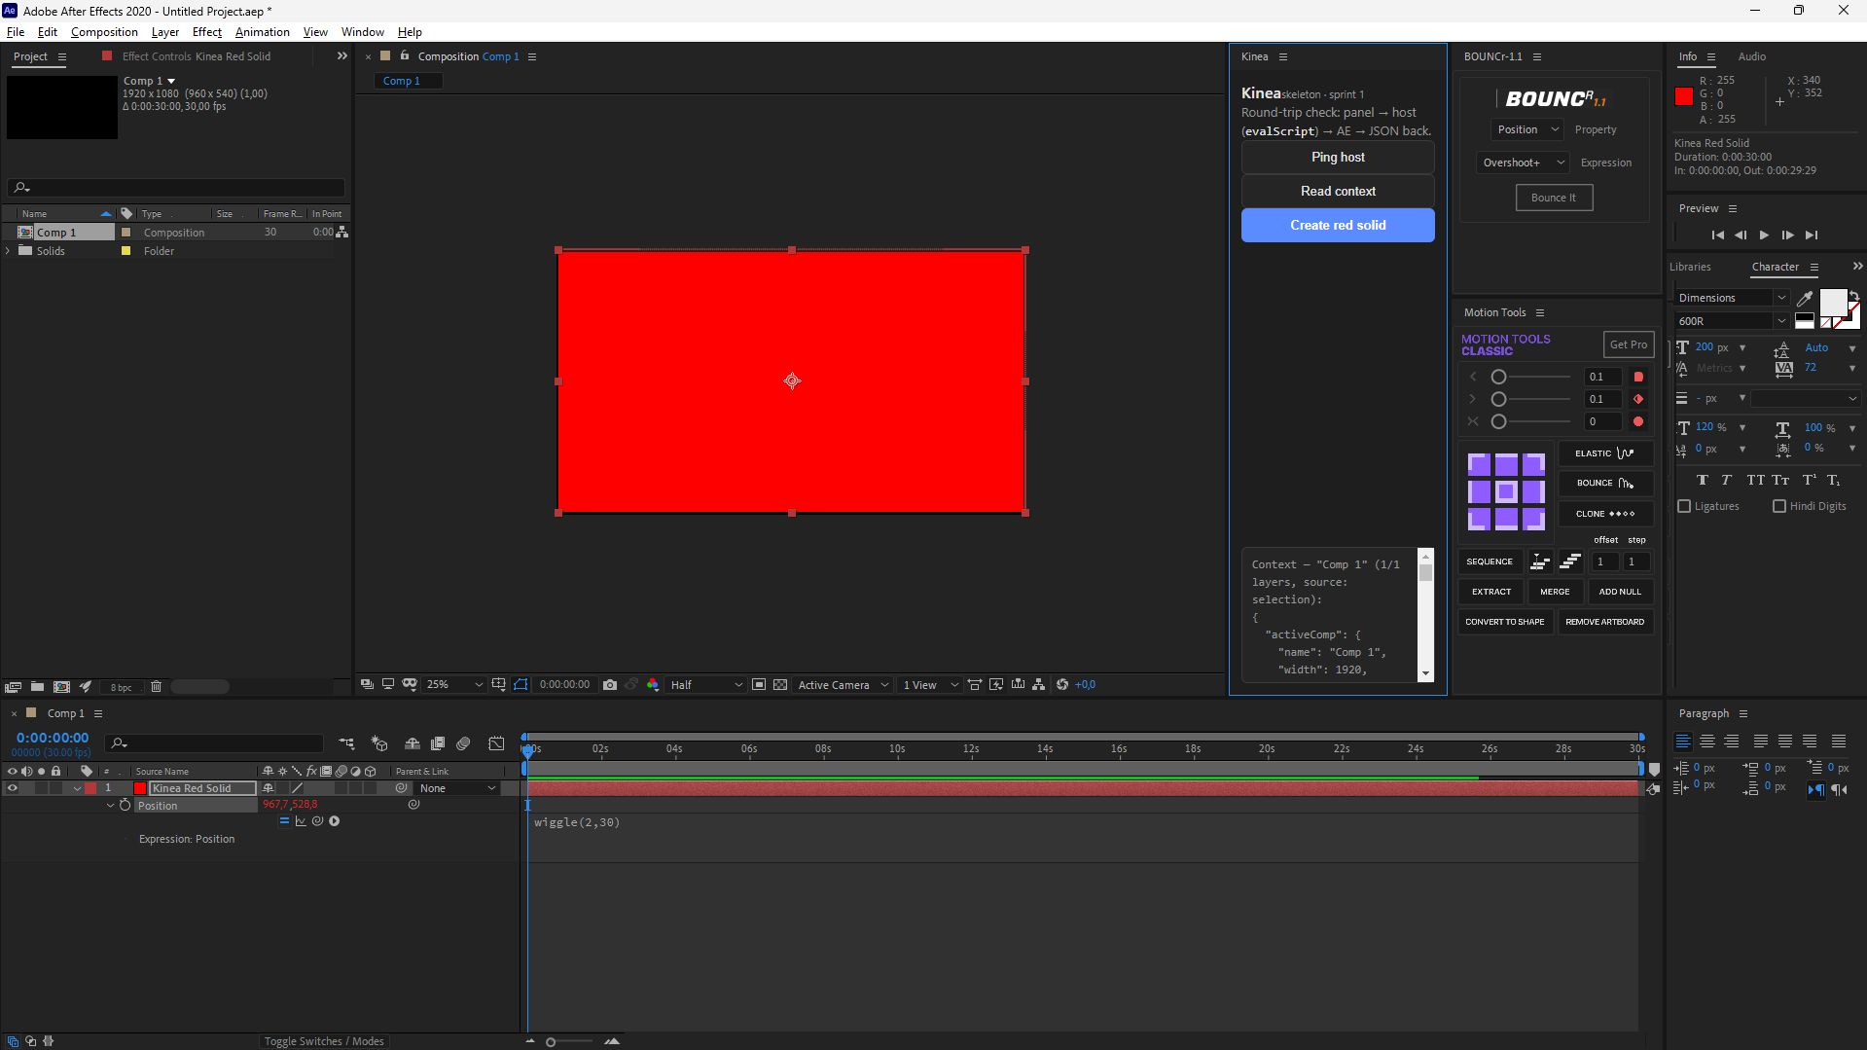
Context — "Comp 1" (1/1 layers, source: selection):
{
"activeComp": {
"name": "Comp 1",
"width": 1920,
"height": 1080,
"frameRate": 30,
"duration": 30,
"currentTime": 0,
"numLayers": 1
},
"layerSource": "selection",
"layers": [
{
"index": 1,
"name": "Kinea Red Solid",
"type": "av",
"enabled": true,
"transform": {
"position": [
967.650067067153,
528.773961019114,
0
],
"scale": [
100,
100,
100
],
"rotation": 0,
"opacity": 100,
"expressions": [
{
"prop": "Position",
"matchName": "ADBE Position",
"expression": "wiggle(2,30)"
}
]
}
}
],
"truncatedLayers": false,
"selectedProperties": [
{
"name": "Position",
"matchName": "ADBE Position",
"value": [
967.650067067153,
528.773961019114,
0
],
"expressionEnabled": true,
"expression": "wiggle(2,30)"
}
],
"projectTree": [
{
"name": "Comp 1",
"layers": 1
}
]
}
4. Coba berbagai tipe layer (text/shape/solid/null/camera) → cek label type benar.
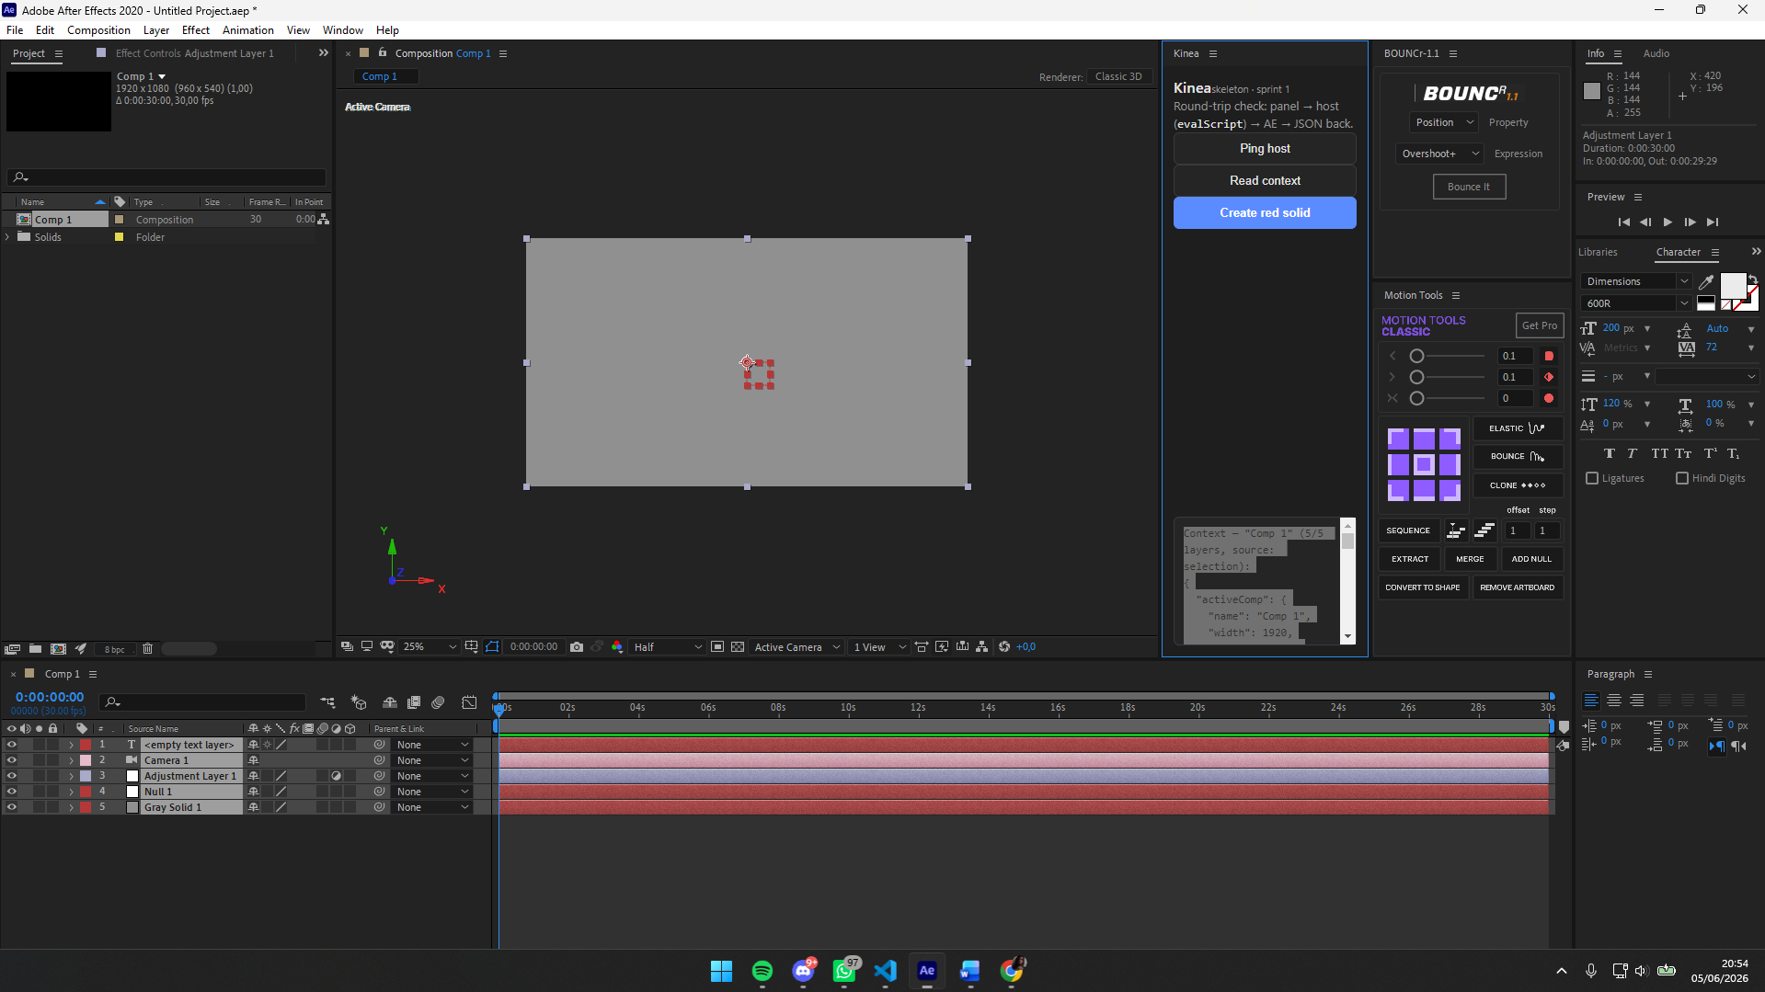
Context — "Comp 1" (5/5 layers, source: selection):
{
"activeComp": {
"name": "Comp 1",
"width": 1920,
"height": 1080,
"frameRate": 30,
"duration": 30,
"currentTime": 0,
"numLayers": 5
},
"layerSource": "selection",
"layers": [
{
"index": 1,
"name": "<empty text layer>",
"type": "text",
"enabled": true,
"transform": {
"position": [
960,
540,
0
],
"scale": [
100,
100,
100
],
"rotation": 0,
"opacity": 100,
"expressions": []
}
},
{
"index": 2,
"name": "Camera 1",
"type": "camera",
"enabled": true,
"transform": {
"position": [
960,
540,
-2666.6666666
],
"scale": [
100,
100,
100
],
"rotation": 0,
"opacity": 100,
"expressions": []
}
},
{
"index": 3,
"name": "Adjustment Layer 1",
"type": "adjustment",
"enabled": true,
"transform": {
"position": [
960,
540,
0
],
"scale": [
100,
100,
100
],
"rotation": 0,
"opacity": 100,
"expressions": []
}
},
{
"index": 4,
"name": "Null 1",
"type": "null",
"enabled": true,
"transform": {
"position": [
960,
540,
0
],
"scale": [
100,
100,
100
],
"rotation": 0,
"opacity": 0,
"expressions": []
}
},
{
"index": 5,
"name": "Gray Solid 1",
"type": "av",
"enabled": true,
"transform": {
"position": [
960,
540,
0
],
"scale": [
100,
100,
100
],
"rotation": 0,
"opacity": 100,
"expressions": []
}
}
],
"truncatedLayers": false,
"selectedProperties": [],
"projectTree": [
{
"name": "Comp 1",
"layers": 5
}
]
}

5. Tanpa comp aktif → harusnya activeComp: null.
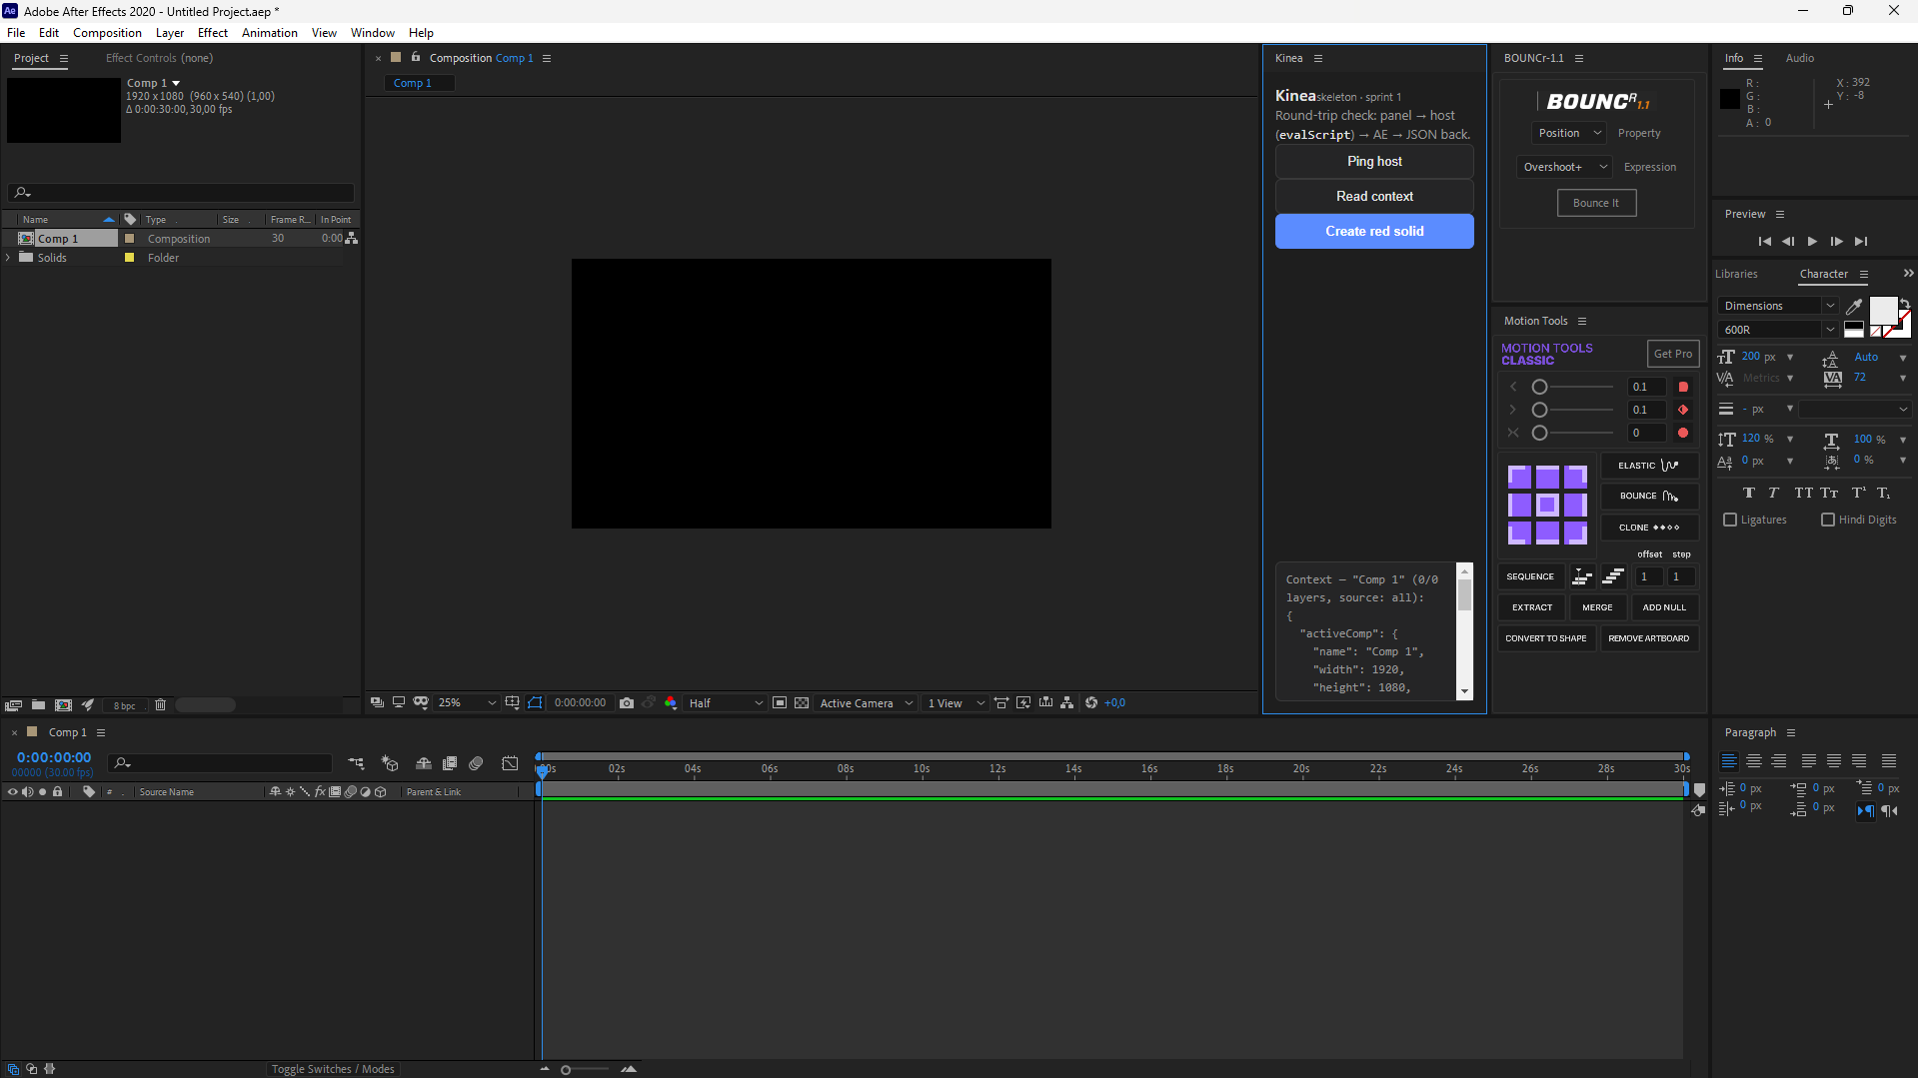
Context — "Comp 1" (0/0 layers, source: all):
{
"activeComp": {
"name": "Comp 1",
"width": 1920,
"height": 1080,
"frameRate": 30,
"duration": 30,
"currentTime": 0,
"numLayers": 0
},
"layerSource": "all",
"layers": [],
"truncatedLayers": false,
"selectedProperties": [],
"projectTree": [
{
"name": "Comp 1",
"layers": 0
}
]
}

